Confocal Scanning Laser Microscope (CSLM)

Instrument details-
Model: Nikon Confocal A1 with upright microscope
Technical details: Nikon Confocal A1, Model 90i, LASER board LU4A, LASER lines 405, 488, 543, 638)

Confocal Microscopy is state-of-art optical imaging technique which increase optical resolution and contrast of a microscopic image by a spatial pinhole in order to block out-of-focus light in image formation. This microscope has controlled and highly limited depth of focus. It captures multiple two-dimensional images at different depths in a sample to enable the reconstruction of three-dimensional structures (in a process known as optical sectioning) within an object. Samples are often treated with fluorescent dyes to make selected objects visible, which give advantage of distinguishing biologically different parts within the sample. Confocal microscopy provides the capacity for direct, non-invasive, serial optical sectioning of intact, thick, living specimens with a minimum of sample preparation as well as a marginal improvement in lateral resolution.

Applications: studies related to-
- Plant-microbe interaction
- Live –dead cell imaging for bacteria
- Tracing of tagged microbes in plant system
- Plant anatomy
- Effects of specific treatments on plant system
- Fungal plant pathogens
- Pathogen-plant interaction
- Pathogen-plant-biocontrol agent interactions

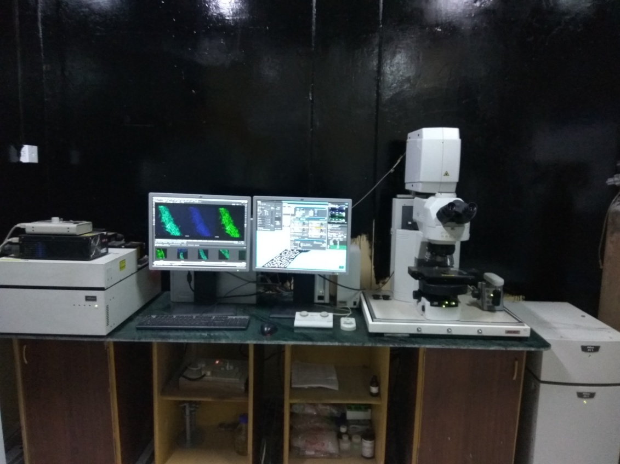
User instructions:
- User have to provide sample in form of slide containing thin section duly treated with required fluorescent dyes
- The service is provided for imaging, thus rates do not include consumables like fluorescent dyes and mounting oil; user have to provide all these consumables required for study
- Error in sample preparation, drying of sample, photo-bleaching, bubbles in slide, etc. are solely responsibility of user, not ICAR-NBAIM
- ICAR-NBAIM do not take any responsibility on technical information required for sample preparation and user have to provide the excitation maxima of fluorescent dye used
- User have to book the slot at least 15 days before
- Slot will be booked only on availability of technical expert
- User have to provide undertaking that samples are not human pathogenic, poisonous, toxic, radioactive or contaminating to instrument/operator
- Director, ICAR-NBAIM reserves all rights to cancel booking at any time without prior information
- The payment should be made in advance only by Demand Draft (DD) in favour of :
"Director, ICAR-NBAIM" payble at Maunath Bhanjan

Contact us:
All requests should be sent to nbaimicar@gmail.com with a copy to pramod15589@gmail.com
Phone: (0547) 2530080 (Ext. 278)

Charges of use:
INR 5000/ session of three hours for academic institutions
INR 8000/ session of three hours for industries and others

