Freeze Dryer
Instrument Details:
Make: MARTIN CHRIST
Models: ALPHA 1-2 LD, ALPHA 1-4 LD, ALPHA 1-4 LD plus, GAMMA 1-16 LSC
Specification:
Ice condenser capacity - max. 4 kg
Ice condenser temperature - Approx. -25 °C to -50 °C
Manifold - 8 to 24 manifold
Working principle:
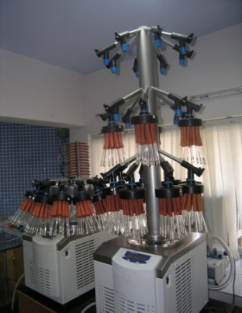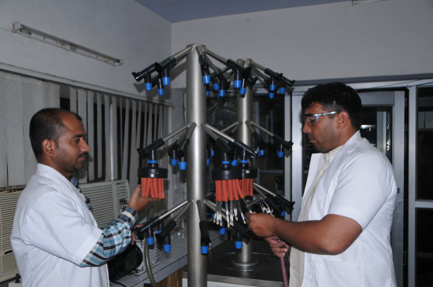
Freeze drying or lyophilization is a highly successful method for preserving bacteria, yeast & the spore of filamentous fungi. During the drying process, water is extracted from frozen material by avoiding the liquid state through sublimation i.e. direct conversion from ice to vapor. This happens under vacuum and the temperature in the product is normally less than -10 °C. Through freeze drying the microorganisms mainly bacteria and fungi are transformed into a dry product. During this process enzymatic and chemical changes are largely avoided. Freeze drying prevents shrinkage, structural change and help to retain viability for about 15 – 20 years based on the storage conditions.
User instructions:
1. A requisition letter addressing The Director, ICAR-NBAIM along with DD of required amount should be sent by post or submitted in person to ICAR-NBAIM office, Post Bag No. 6, Kushmaur, Mau – 275103.
2. After the receipt of requisition letter along with DD in ICAR-NBAIM office your samples will be scheduled for process as per the queue.
3. The user should give the details of conditions for cultivation/sporulation of bacterial and fungal cultures along with the requisition letter.
4. The users are requested to send the microbial cultures in the form of slants
Contact Us:
Tel.: 0547-2530080
E-mail:
Charges:
S. No | Categories | Price (INR) / 10 ampoules of each culture
1. | Educational/Govt. Research Institute/University under Govt., non-profit organization, etc. | 2500/-
2. | Private institute/Others | 10000/-

