3130 Genetic Analyzer (3130 XL)

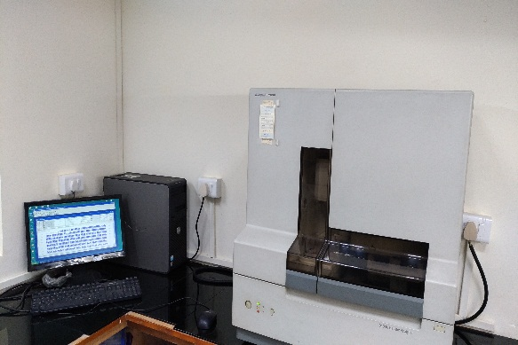
Instrument Details:

Make: Applied Biosystems

Model: 3130 XL

Specification:
Analysis Software: | GeneMapper® Software
Capillary Length: | 80cm
Compatible Polymers: | POP-7
Chemistry: | BigDye®Terminator V. 3.1
Format: | 96-well plate
Number of Capillaries: | 16 Capillaries
Operating Environment: | Humidity: 20%-80%, Temperature: 15°C-30°C
Operating System: | Microsoft Windows 7
Performance: | 98.5% basecalling accuracy

Contact us: 0547 2530358

e. mail: nbaimicar@gmail.com, aloksrivastva@gmail.com

Charges:
S.No. | Description | Rates for Academic Research Purpose | Rates of Industry
1. | Partial sequencing of purified PCR products | INR 1500.00 per sample | INR 5000.00 per sample

