High Performance Liquid Chromatography (HPLC)
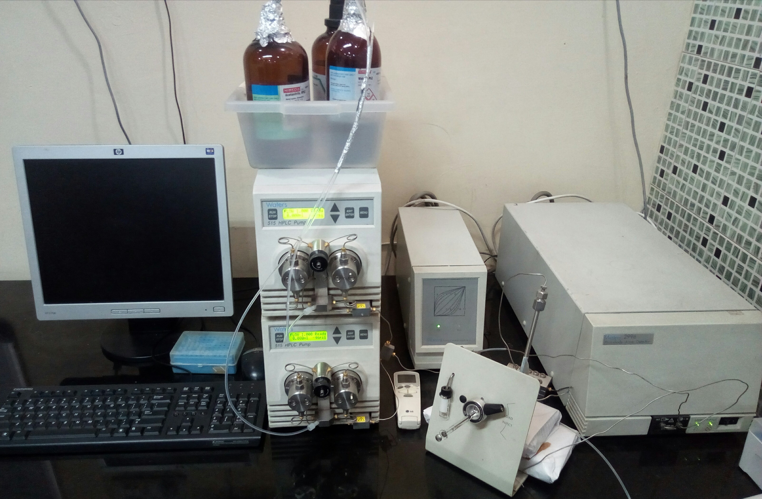
Make : Waters, USA
Model : Waters 2996 with 515 reciprocating pump and system controller
Specification : Binary HPLC System with PDA detector
Working Principle : Chromatography is basically a separation technique being used for separating complex mixture of compounds into their individual components based on the physical and chemical properties. Separation of compounds essentially requires a Mobile (solvent) and Stationary phase (immobile material). The mixture of analytes travels across the Stationary phase with mobile phase and based upon the polarity, charges, molecular weight and functional groups, get separated from the mixture. HPLC is a high resolution chromatographic method which involves the Stationary phase of very small particle size (~5µm) which does not allow mobile phase containing analytes to pass through without high pressure. Under given conditions, the analysis remains efficient, reliable and reproducible for most of the compounds therefore, the instrument is inevitable for the qualitative and quantitative targeted metabolite characterization and profiling in plants, microbes and other biological samples. Photodiode array detector attached with the system projects 3-D absorption over UV-VIS range and therefore, improves accuracy and efficiency of detection.
Major Features : Dual pump HPLC coupled with PDA detector coupled with C-8, C-18, Amino columns and EMPOWER software for data generation, suitable for isocratic and gradient analysis of plant and microbial samples for secondary metabolic profiling, qualitative characterization of compounds and quantitative analysis of targeted metabolites.
Applications : Qualitative metabolite profiling, Quantitative analysis of compounds of interest, Impurity check, Metabolites of herbal and food products, Pharmacokinetics applications, Plant and microbial metabolite studies
Prior requirements : Nature of the samples, information about the running conditions, source of compound and mixture, chemical standards, UV spectra of the metabolite or mixture (200-700 nm)
Charges (INR) :

S. No. | Operating Conditions | Charges (Rs.)
S. No. | Operating Conditions | Academic users | Industry users
1. | Isocratic run for single compound or mixture (< 20 min) | 400 | 600
2. | Isocratic run for metabolite/mixture (<20 min) | 600 | 800
3. | Gradient run for metabolite mixture (<30 min) | 800 | 1000
4. | Gradient run for metabolite mix (>30 min) | 1200 | 1500

Terms & conditions : It is advisable to discuss about the samples and separation conditions prior to proceed for submission of samples for analysis. Loss or degradation of samples during transportation shall not be the responsibility of ICAR-NBAIM.

****

