Scanning Electron Microscope (SEM)
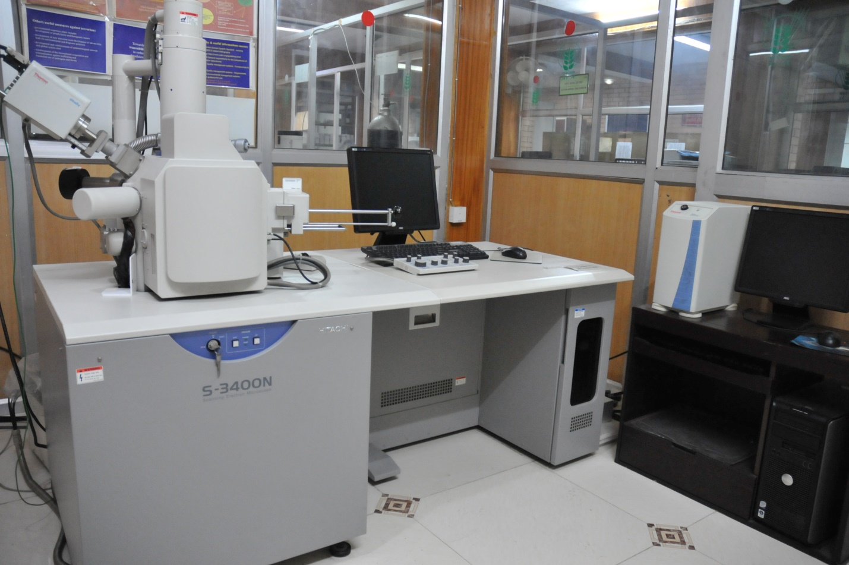

Instrument details
Model | : | Hitachi S-3400N
SEI Resolution | : | 3.0nm (30kV, in high vacuum)  10nm (3kV, in high vacuum)
BSEI Resolution | : | 4.0nm (3kV, in low vacuum)
Magnification | : | 5x to 300,000x
Accelerating Voltage | : | 300V to 30kV
Working Principle
SEM is a microscope which uses an electron beam to produce the surface image of the object with high magnification obtained by electromagnetic fields. The Hitachi 3400N VP-SEM is a Scanning Electron Microscope with tungsten filament allowing accelerating voltages up to 30kV. It is equipped with both Secondary (SE) and Backscatter (BSE) Electron Detectors and has a fully eccentric 5 axis motorized stage that allows samples up to 5cm in diameter. The Variable Pressure mode allows BSE observation from 6- 270Pa.

Contact Us
Senior Technical Assistant:
Contact: 0547-2530080
Email: manish.roy@icar.gov.in, manish.nbaim@gmail.com

In-charge, NAIMCC
Contact: 0547-2530156
Email: sks_micro@rediffmail.com;

Director
Contact: 0547-2530080
Email: director.nbaim@icar.gov.in; saxena461@yahoo.com;

Instructions
- A requisition letter should be addressed to The Director, ICAR-NBAIM along with DD of required amount should be sent by post or submitted in person to ICAR-NBAIM office, Post Bag No. 6, Kushmaur, Mau – 275 103. After the receipt of requisition letter along with DD in ICAR-NBAIM office your samples will be scheduled for process as per the queue.
- The users are requested to communicate to the contact person of the instruments before floating requisition and sending samples for analysis.
- If you are not supposed to be present at the time of appointment please mention as much details as possible like
  - Expected features you are looking for. (If available send a representative pictures/related paper etc. also)
  - Up to what magnification images you want.
  - About nature of your sample like whether it is conducting OR non-conducting.
  - If it needs to be dispersed in any solvent (for powdered sample). (If required attach a separate sheet.)
- Once your Requisition letter along with DD will be received in ICAR-NBAIM, then only you can be given an idea of tentative date of appointment.
- The users will be informed about their date & time of slot by e-mail.
- The samples should be dry and should withstand high vacuum (~ 10 -5 Pa). Wet biological sample can’t be done.
- The sample size should be less than 12.5 mm x 12.5 mm x 10 mm (height) and the side opposite, the side of interest, should be flat (to enable sample mounting). The smaller the sample height the better the result.
- The user is welcome to be present in the laboratory during analysis.

Charges

SEM Services |  | Category I  [Educational/Govt. Research Institute/University under Govt., non-profit organization, etc. (INR)] | Category II  [Private institute/Others (INR)]
Surface characterization by Scanning Electron Microscope | High Vacuum Mode
Surface characterization by Scanning Electron Microscope | Sample preparation & SEM Viewing | ₹1500.00  (Per Sample) | ₹8000.00  (Per Sample)
Surface characterization by Scanning Electron Microscope | Sample preparation, SEM Viewing & EDX | ₹3000.00  (Per Sample) | ₹9000.00  (Per Sample)
Surface characterization by Scanning Electron Microscope | Low Vacuum Mode
Surface characterization by Scanning Electron Microscope | SEM Viewing Time per hr. (including specimen  preparation, if required) | ₹2500.00  (Per Sample) | ₹9000.00  (Per Sample)
Surface characterization by Scanning Electron Microscope | Biological Sample Preparation  (Fixation, dehydration, critical point  drying and coating): | ₹1000.00  (Per Sample) | ₹1000.00  (Per Sample)
Important Note

- Biological samples will be accepted only.
- Ten images per sample would be provided. Hereafter, ₹ 50/- would be charged extra per image.
- The thickness of samples may be upto 1cm₃.
- Fixation may be done in 2.5 % Glutaraldehyde and 2% paraformaldehyde made in 0.1 M sodium phosphate buffer (pH 7.2). The fixed sample should be brought at ICAR-NBAIM in fixative or in phosphate buffer at 4°C preferably between 10 am to 5 pm (Working days).
- Only 5 samples per requisition form will be accepted.
- Dispatch charges: If CD to be posted, ₹100/- as postage (Speed Post) charges will be extra

 | jk"Vªh; d`f"k mi;ksxh lw{etho C;wjks  NATIONAL BUREAU OF AGRICULTURALLY IMPORTANT MICROORGANISMS  Hkkjrh; d`f"k vuqla/kku ifj"kn~  (Indian Council of Agricultural Research)  dqlekSj] eÅ ukFk Hkatu] mRrj izns’k&275101  Kusmaur, Mau Nath Bhanjan, Uttar Pradesh- 275101  Tel ¼nwjHkk"k½: (0547) 2530080, FAX ¼QSDl½: (0547) 2530381,  E-Mail ¼bZ&esy½: nbaimicar@gmail.com, (Web): www.nbaim.org | 

Requisition form for utilization of ICAR-NBAIM SEM facility

Requisition for  (Please tick) |  |  | Requisition No.__________________________________  (To be filled by ICAR-NBAIM)
SEM  ( ) |  | SEM & EDX  ( )
 | Name, Designation & Address of Investigator with telephone number |  | ____________________________________________  ____________________________________________
 | Name & designation of user with telephone number |  | ____________________________________________  ____________________________________________
 | Category I  [Educational/Govt. Research Institute/University under Govt., non-profit organization, etc.] |  |  |  | (Please tick) ( )
 | Category II  [Private institute/Others] |  |  |  | (Please tick) ( )
 | Name of the specimen/tissue |  | ______________________________________________  (Microorganisms & others related)
 | Name of the fixative used |  | __________________________________________  Duration ______________________________(Minutes/Hrs.)
 | Number of specimen to be processed |  | ______________________  Orientation ______________________
 | Purpose of utilizing  ICAR-NBAIM SEM facility |  | __________________________________________  __________________________________________
 | Name of the project or title of the proposed thesis/dissertation work and date of completion |  | __________________________________________  __________________________________________
 | UNDERTAKING: Please give details of previous publications, if any, emerging out of the work carried out at the ICAR-NBAIM SEM facility by your group. The investigator is requested to certify that he/she acknowledge ICAR-NBAIM for utilization of this facility in the publication emanated in due course of time. |  | __________________________________________  __________________________________________  __________________________________________  __________________________________________  __________________________________________
Signature of Officer-in-Charge  ICAR-NBAIM SEM Facility |  |  |  | Signature of Indenter
 |  |  |  | Date …………………………..

Note:
Fixation is to be done in 2.5% Glutaraldehyde and 2% paraformaldehyde, made in 0.1M sodium phosphate buffer (pH 7.4) for about 12 hrs. at 4ᵒC. The fixed specimen should be transported in phosphate buffer.

